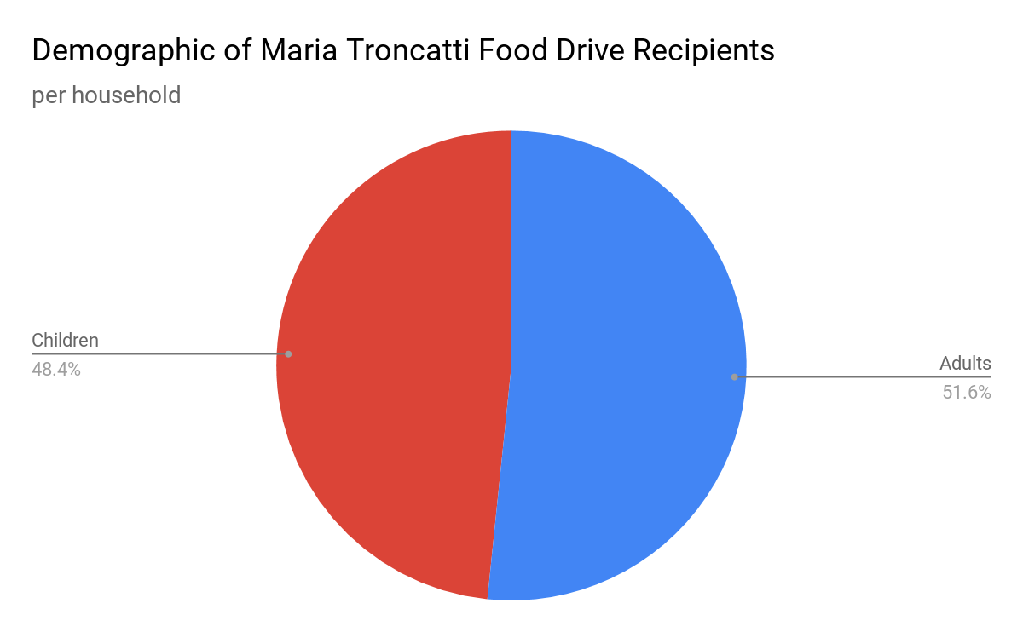
Out of the 110 families, 221 of the people served are adults, while 207 are children.

